Chemistry 141 Name
Exam 3A April 20, 2006

Multiple Choice (20 points)

Page 1 (18 points)

Page 2 (18 points)

Page 3 (19 points)

Page 4 (18 points)

Page 5 (10 points)

Page 6 (25 points)

Total (108 points)

Chemistry Formulas and Constants

w = -PΔV
P_{total} = P₁+P₂+P₃+…
u = (3RT/MW)^{½}
ΔG = ΔH - TΔS
PV = nRT
Rate ∝ (MW)^{-½}
P₁=X₁*P_{total}
C = q/ΔT
P_{total} = P₁ + P₂ + P₃ + …
M = mol/L
K = ºC + 273.16
m = mol/kg solvent
X_{i} = mol_{i}/ mol_{total}
Kinetic Energy =½mv² = ³/₂ RT
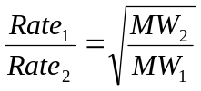
ΔE = q + w

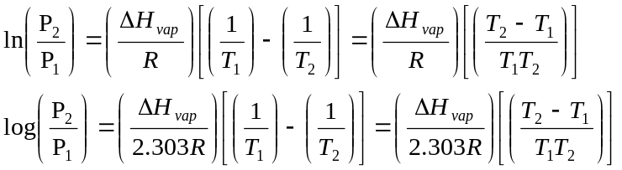
1 kcal = 4.184 kJ
N_{A} = 6.02 x 10²³ /mol
R = 0.0821 L atm/mol K = 62.4 L torr/mol K = 8.31 kJ/mol K
Standard Temperature and Pressure = 0ºC and 1 atm
760 torr = 760 mm Hg = 1.00 atm = 101 kPa = 14.6 psi = 30 in Hg
Specific heat water = 4.184 J/mol K
ΔH_{vaporization} (H₂O) = 2260 J/g

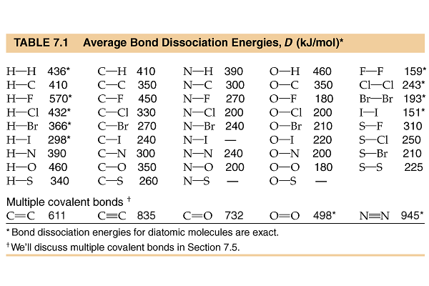
substance | Heat of formation (kJ/mol)
C₂H₂(g) | 226.7
CO₂(g) | -393.5
C₂H₆(g) | -83.8
H₂O(l) | -285.8
H₂O(g) | -241.8
 | Specific Heat (J/g oC)
H₂O(l) | 4.184
H₂O(s) | 2.0
Al(s) | 0.902

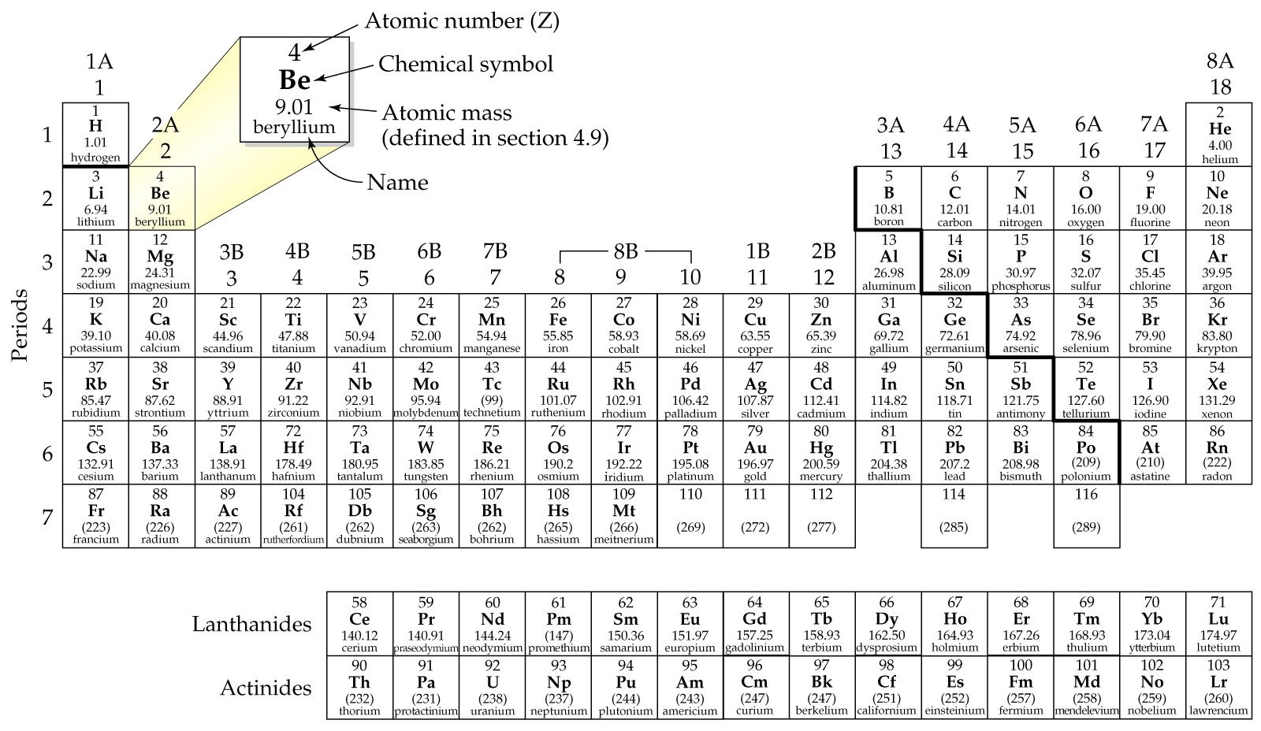

Part I - Multiple Choice (20 points)

- Which equation represents the reaction whose ΔH, represents the standard enthalpy of formation of CHCl3(l) at 25ºC? (i.e., for which is ΔH = ΔHºf of CHCl3)
  - C(s) + 1/2 H2(g) + 3/2 Cl2(g) → CHCl3(l)
  - CHCl3(l) → C(s) + H(g) + 3 Cl(g)
  - C(s) + H(g) + 3 Cl(g) → CHCl3(l)
  - 2 C(s) + H2(g) + 3 Cl2(g) → 2 CHCl3(l)

- The reaction 4 Ag(s) + O2(g) → 2 Ag2O(s) favors Ag2O at low temperature, but it favors Ag and O2 at high temperatures. How can this be explained in terms of ΔH and ΔS?
  - ΔH is negative and ΔS is positive.
  - ΔH is positive and ΔS is negative.
  - ΔH is negative and ΔS is negative.
  - ΔH is positive and ΔS is positive.

- Some assumptions from the kinetic molecular theory are listed below. Which one is most frequently cited to explain compressibility of a gas?
  - A gas consists of tiny particles moving in random straight line motion.
  - The volume of the particles is negligible compared to the volume of the gas.
  - The average kinetic energy of gas particles is proportional to the Kelvin temperature.
  - Collisions of gas particles are elastic and total kinetic energy of the gas is constant.

- You are given two flasks of equal volume. One contains H2 at 0ºC and 1 atm while the other contains CO2 at 0ºC and 2 atm. Which of the following quantities will be the same for both flasks?
  - average molecular speed
  - number of molecules present
  - density
  - average molecular kinetic energy

- In an open end manometer, one end of a U-tube filled with mercury is attached to a gas-filled container and the other end is open to the atmosphere. If the gas pressure in the container is less than atmospheric pressure
  - the difference between the Hg levels in the two arms will be greater than 76 cm.
  - Hg will be forced out of the open end of the U-tube.
  - the Hg level will be higher in the arm connected to the container.
  - the Hg level will be higher in the arm open to the atmosphere.

- Arrange the following in order of increasing boiling point.
CH3CH2OH CH3CH2CH3 H3C-O-CH3 CH3CH2NH2
I II III IV
  - IV < III < II < I
  - II < III < I < IV
  - II < III < IV < I
  - I < IV < III < II

- The normal boiling point for HI is higher than the normal boiling point for HBr. This can be explained by
  - larger dipole-dipole forces, larger dispersion forces, and larger hydrogen-bond forces for HI.
  - larger hydrogen-bond forces for HI.
  - larger dipole-dipole forces for HI.
  - larger dispersion forces for HI.

- For which should the standard heat of formation Hºf, be zero at 25ºC?
- O2(g) | - O3(g) | - O(g) | - all the above

- Which of the following is not a state function?
  - internal energy
  - altitude
  - volume
  - work

Use the following diagram to answer question 10

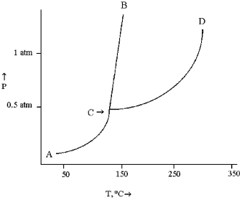
- According to the diagram, the solid phase of this substance
  - is more dense than the liquid phase.
  - is less dense than water.
  - has the same density as the liquid phase.
  - is less dense than the liquid phase.

Part II - Short Answer ( points)

- (7 points) A mercury mirror forms inside a test tube by the thermal decomposition of mercury (II) oxide:

2 HgO (s) → 2 Hg(l) + O₂(g) ΔH = 181.6 kJ

  - This reaction is (circle one): ENDOTHERMIC or EXOTHERMIC

  - If 275 kJ of heat is consumed, how many grams of mercury form?

- (5 points) What is the change in internal energy (in J) of a system that absorbed 522 J of thermal energy from its surroundings and did 0.264 kcal of work on the surroundings? (Think about the sign!)

- (6 points) Given the following Diels Alder reaction
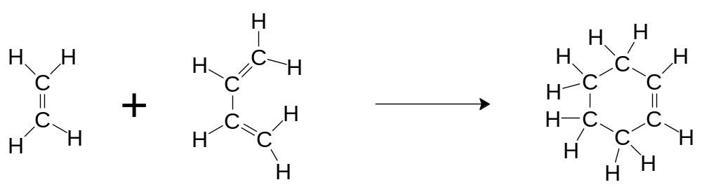

Use bond energies to estimate the enthalpy of reaction. (Look for clever ways to get there.)

- (10 points) Given the chemical reaction for the hydrogenation of ethane, determine ΔH_{rxn} by two different methods

C₂H_{2(g)} + 2H_{2(g)} → C₂H_{6(g)}

  - Find the enthalpy of the reaction using heat of formation data on the front page.

  - Find the enthalpy of reaction using Hess’ Law and the equations below

2C₂H_{2(g)} + 5O_{2(g)} → 4CO_{2(g)} + 2H₂O_{(l)} ΔH_{rxn} = -2600 kJ
2C₂H_{6(g)} + 7O_{2(g)} → 4CO_{2(g)} + 6H₂O_{(l)} ΔH_{rxn} = -3120 kJ
H_{2(g)} + ½O_{2(g)} → H₂O_{(l)} ΔH_{rxn} = -285 kJ

- (8 points) Calculate the heat produced per mole of glucose when 1.80 g of C₆H₁₂O₆ are combusted with excess oxygen in a bomb calorimeter containing 3.50 kg of water. The temperature change measured is 1.68 ºC. The heat capacity of the calorimeter is 2050 J/ºC .

- (10 points) Steam burns are very painful, mostly because of the heat transferred during condensation of the steam into liquid water.
  - How much heat is transferred to the body if one gram of steam at 100 ºC condenses and cools to body temperature (37 ºC)?

  - What percentage of this value is due to the condensation of steam?

- (9 points) Calcium carbonate reacts with hydrochloric acid to produce carbon dioxide gas. If 35.3 g of calcium carbonate reacts with 100 mL of 6.00 M HCl, how many liters of carbon dioxide gas will be produced at 745 mmHg and 23.0oC?

CaCO₃ (s) + 2 HCl (aq) → CO₂ (g) + H₂O (l) + CaCl₂ (aq)

- (8 points)Two flasks at the same temperature are joined by a glass tube with a stopcock. Flask A is a 4.0 L flask containing N2(g) at 2.0 atm, while flask B is a 10.0 L flask containing CO(g) at 1.3 atm.

  - What is the pressure of N₂ and CO gas once the stopcock was opened

  - What is the final pressure in the flasks after the stopcock is opened?

  - What is the mole fraction of N₂ (g) after the stopcock is opened

- (10 points) Solid thorium(IV) fluoride has a boiling point of 1680ºC.
  - What is the density of a sample of gaseous thorium(IV) fluoride at its boiling point under a pressure of 2.5 atm in a 1.70 L container?

  - Which gas will effuse faster at 1680 ºC, thorium(IV) fluoride or uranium(III) fluoride? How much faster?

- 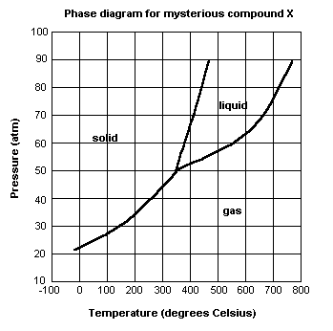(10 points) For the next questions refer to the phase diagram for mysterious compound X.

  - What is the critical temperature of compound X? ___________

  - If you were to have a bottle containing compound X in your closet, would it most likely be a gas, liquid, or solid?

  - At what temperature and pressure will all three phases coexist?

  - A bottle of compound X is stored at a pressure of 45 atm and temperature of 100⁰ C, what will happen if the temperature increases to 400⁰ C?

  - Why can’t compound X be boiled at a temperature of 200⁰ C?

- (5 points) The nonpolar hydrocarbon C₂₅H₅₂ is a solid at room temperature. Its boiling point is greater than 400ºC. Which has the stronger intermolecular forces, C₂₅H₅₂ or H₂O? Explain your reasoning.

- (12 points) In each of the following groups of substances, circle the one that has the given property. Justify your answer.
  - Lowest vapor pressure at 25ºC: Cl₂, Br₂, or I₂

  - Highest boiling point: CH₃OCH₃, CH₃CH₂OH, or CH₃CH₂CH₃

  - Lowest freezing point: N₂, CO, or CO₂

- (8 points) Consider three identical flasks filled with different gases.
Flask A: CO at 760 torr and 0ºC
Flask B: N₂ at 250 torr and 0ºC
Flask C: H₂ at 100 torr and 0ºC
  - In which flask will the molecules have the greatest average kinetic energy? Explain your reasoning.

  - In which flask will the molecules have the greatest average velocity? Explain your reasoning.

